To: All Universal Credit Portal Landlords
Date: March 2023

Social Rented Sector – April 2023 Annual Rent Changes Update:
In 2023 you will need to verify all annual rent changes reported by tenants.
As in 2022 the to-do will be issued to landlords via the Portal for all portal-managed claimants.
The to-do will be visible in your Portal to-do list and will be called ‘Confirm tenant’s housing costs’. It will be possible to filter/search for this to-do using the current filter and search functionality in the Portal. To-dos will be listed by AP end date to help you prioritise the list.
The following screens explain the information you will be asked to provide. This includes:
• Whether the claimant is your tenant and liable for housing costs at the address stated
• Frequency of rent and the rent liability
• Whether service charges are liable, and the frequency and amount of charges
• The date the changes are effective from
Once completed, the information will be presented to you to review, and amend if necessary, before submitting the to-do. Please be aware that if the claimant has an outstanding ‘Provide tenancy details’ to-do, this should be completed before completing the ‘Confirm tenant’s housing costs’ to-do. ‘Provide Tenancy Details’ contains information not in the shortened to-do and is required before we can update the details, we hold via Confirm Tenants Housing Costs.

‘Report tenant’s current housing costs’ to-do
The 'Report tenant's current housing costs' button will remain available within the landlord portal to report non-annual rent changes. This means you can continue to correct housing costs whilst annual rent change verifications are taking place.

Screen 1 – Confirmation of Address & Housing Cost Liability
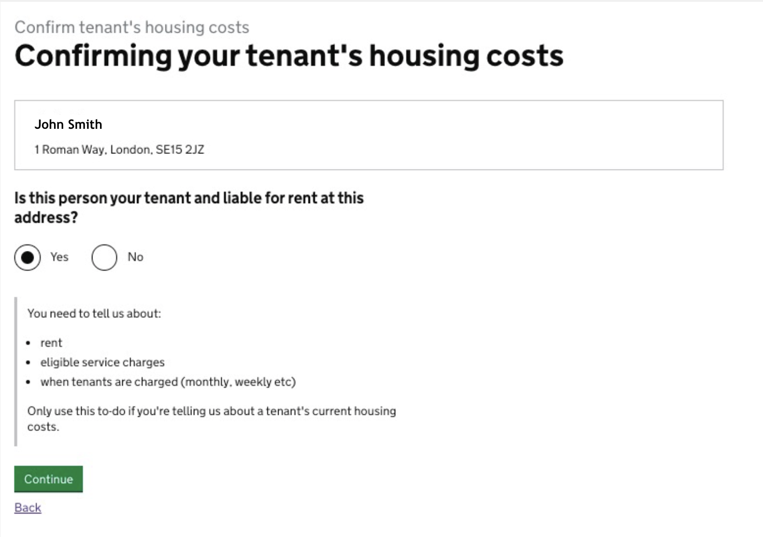

Screen 2 – Provide Rent, Service Charge & Effective Date Information
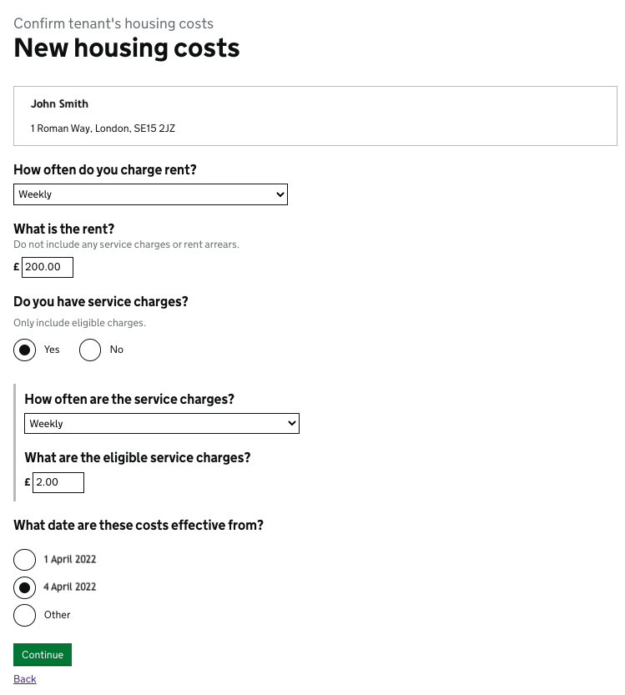

Screen 3 – Check & Submit
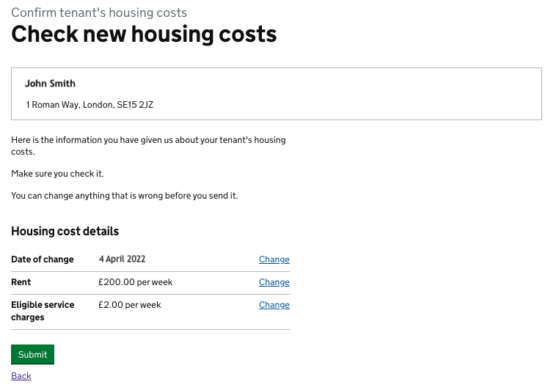

Below, you will find an FAQ to answer any questions you may have. Further information will be available via the Portal.
Q: When can claimants report a change to their rent?
A: All changes need to be made once they have happened (i.e. after the rent has changed in April). We would be grateful if you can remind your tenants of the information, they need to report to their UC account and the date of this change in any communications. Claimants will receive a to-do asking for the information.
Q: Will SRS landlords be able to upload their own lists of tenants’ rent changes?
A: No. The Portal does not support this.
Q: Will I need to re-apply for any APA and third-party deductions or will they automatically continue once a claimant reports any changes in housing costs?
A: As long as the address is the same (i.e. this is a change of housing costs only and not a change of circumstances), APAs and third-party Deductions will continue.
Q: Our rents will not change on the 1st April, they will change at a point later in the year, what do we do?
A: Reporting rent changes remains claimant responsibility. We are exploring options for non-April rent changes, however, at present we are only able to offer a service that supports when the majority of rents change (April).
Q: Will a UC claimant be required to give a breakdown of rent and service charges, or just the total rent chargeable?
A: It’s important your tenants can distinguish between eligible and non-eligible service charges as they will be asked to provide details of the amount of rent they are charged, and then the amount of eligible service charges.
Q: Will the claimant have to provide details about the number of bedrooms, rent free weeks, or who is on the tenancy etc. when they complete the To-do?
A: No.
Q: How will Absent Joint Tenancies work?
A: Please see separate guidance on Absent Joint Tenancies available here: Changes-to-Absent-Joint-Tennants-Dec-2022.docx
Q: We have overcharged and/or undercharged our tenants rent amounts; can we use the portal to correct this?
A: No, the Portal does not support this. If you have any issues with historical payments you should contact your local partnership manager for advice. If you are unsure who your Partnership Manager is, or of the relevant escalation route contacts, please use the following link for further information: https://www.gov.uk/government/publications/dwp-partnerships/national-partnership-teams

